**ADVANCED DATABASE TECHNOLOGY**

**ASSIGNMENT OF UNIT – 5**

Name: Johanan Joshua

Reg. no: 2347119

Class: 1 MCA ‘A’

1. Data Definition Language (DDL) commands with examples.

**DDL (Data Definition Language):** Data Definition Language (DDL) is a subset of SQL and a part of DBMS (Database Management System). DDL consists of Commands to commands like CREATE, ALTER, TRUNCATE, and DROP. These commands are used to create or modify the tables in SQL.

**DDL Commands:**

1. Create: This command is used to create a new table in SQL. The user must give information like table name, column names, and datatypes.

Syntax:

CREATE TABLE table_name

(

column_1 datatype,

column_2 datatype,

column_3 datatype,

....

);

Example:

CREATE TABLE Student_info

(

College_Id numeric(2),

College_name varchar(30),

Branch varchar(10)

);

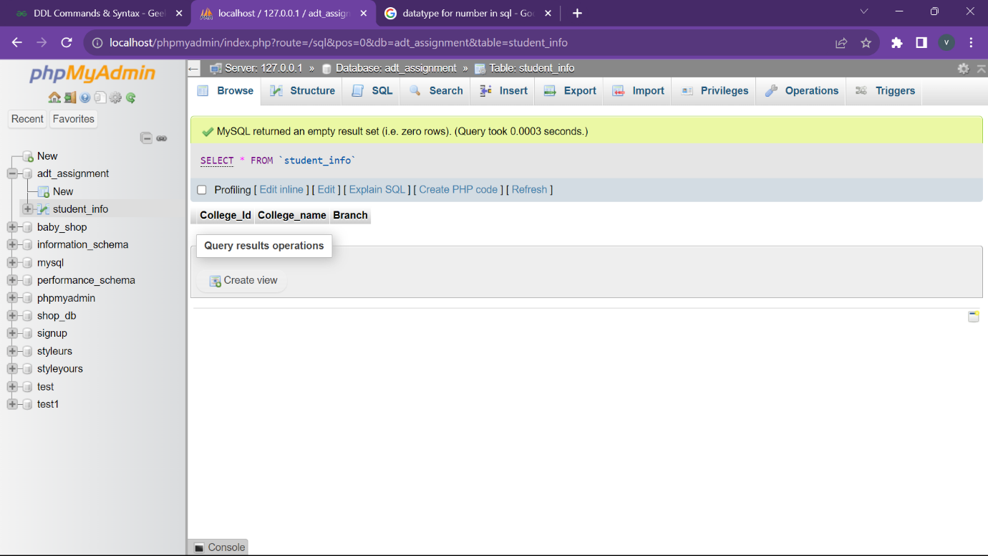

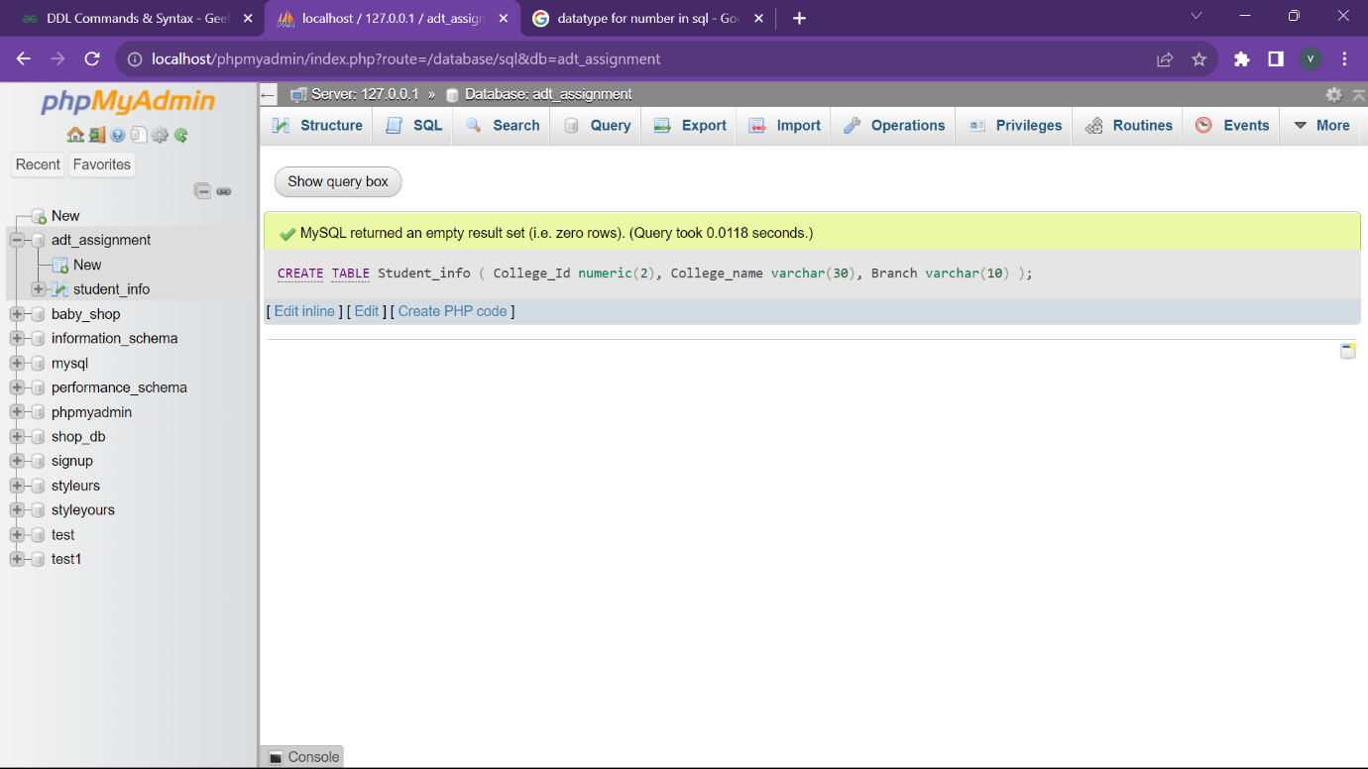

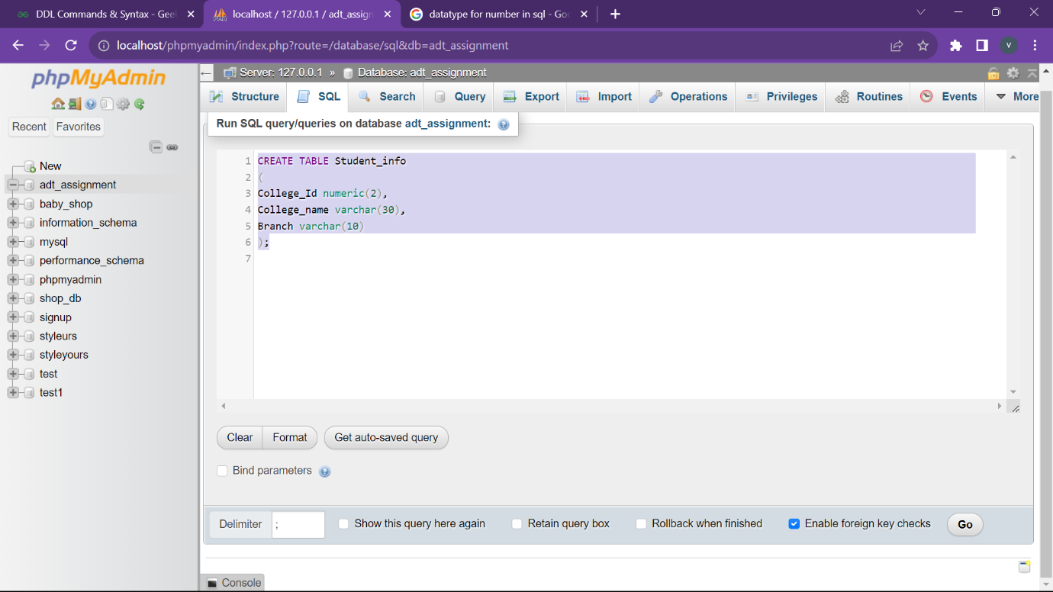

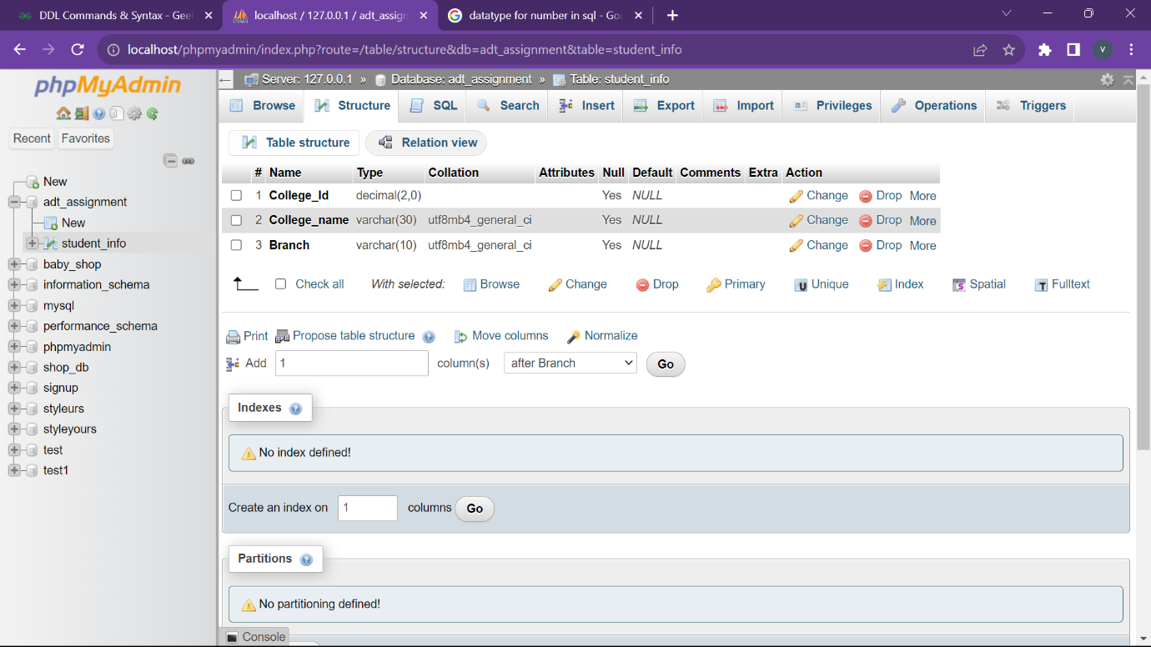

1. **Alter:** This command is used to add, delete, or change columns in the existing table. The user needs to know the existing table name and can add, delete or modify tasks easily.

Syntax:

ALTER TABLE table_name

ADD column_name datatype;

Example:

ALTER TABLE Student_info

ADD CGPA number;

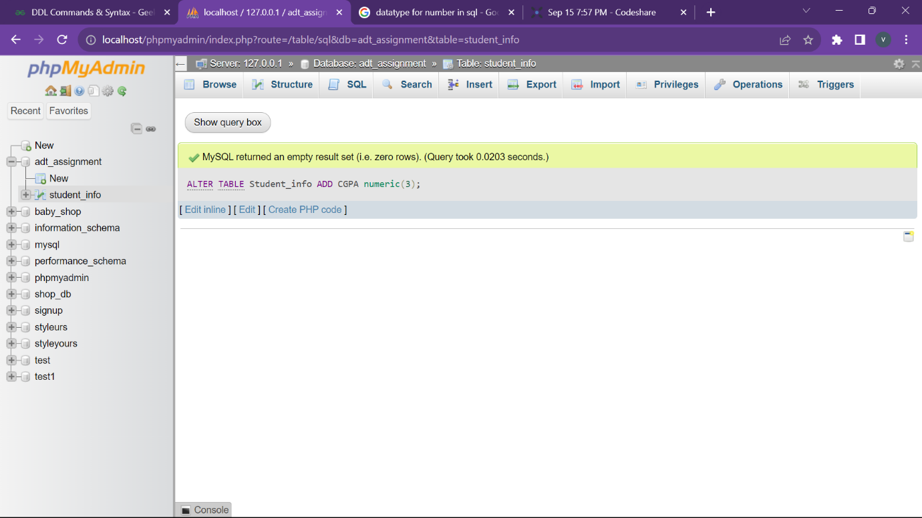

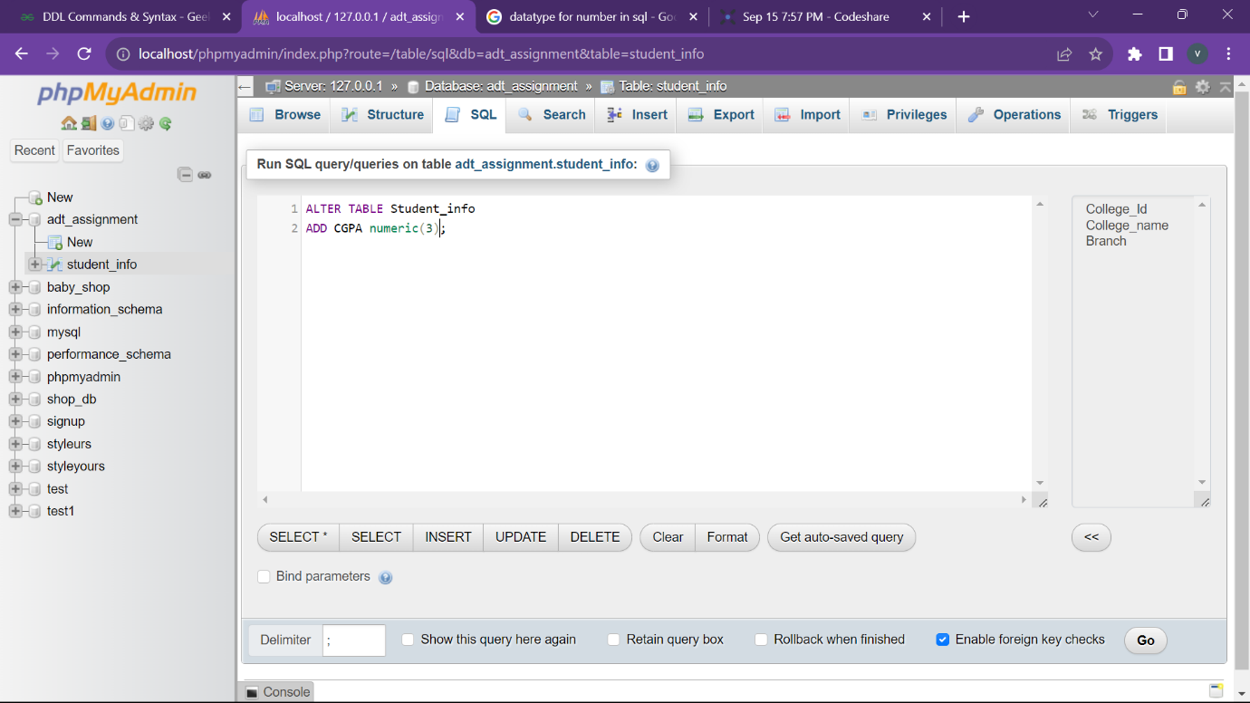

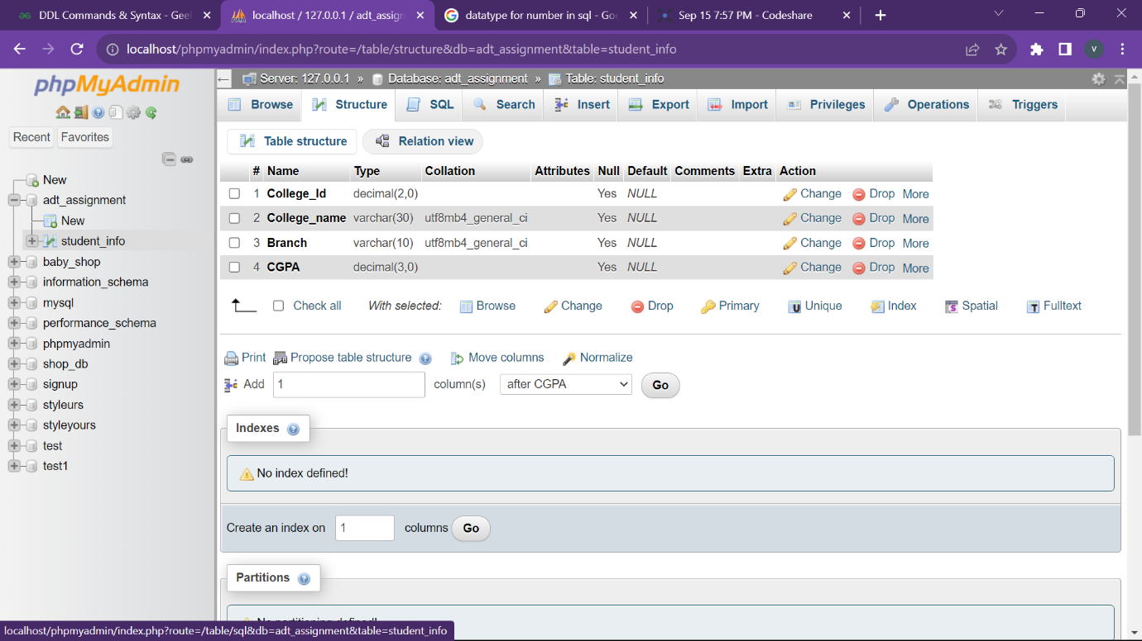

1. **Truncate:** This command removes all rows from the table, but the table's structure still exists.

Syntax: TRUNCATE TABLE table_name;

Example: TRUNCATE TABLE Student_info;

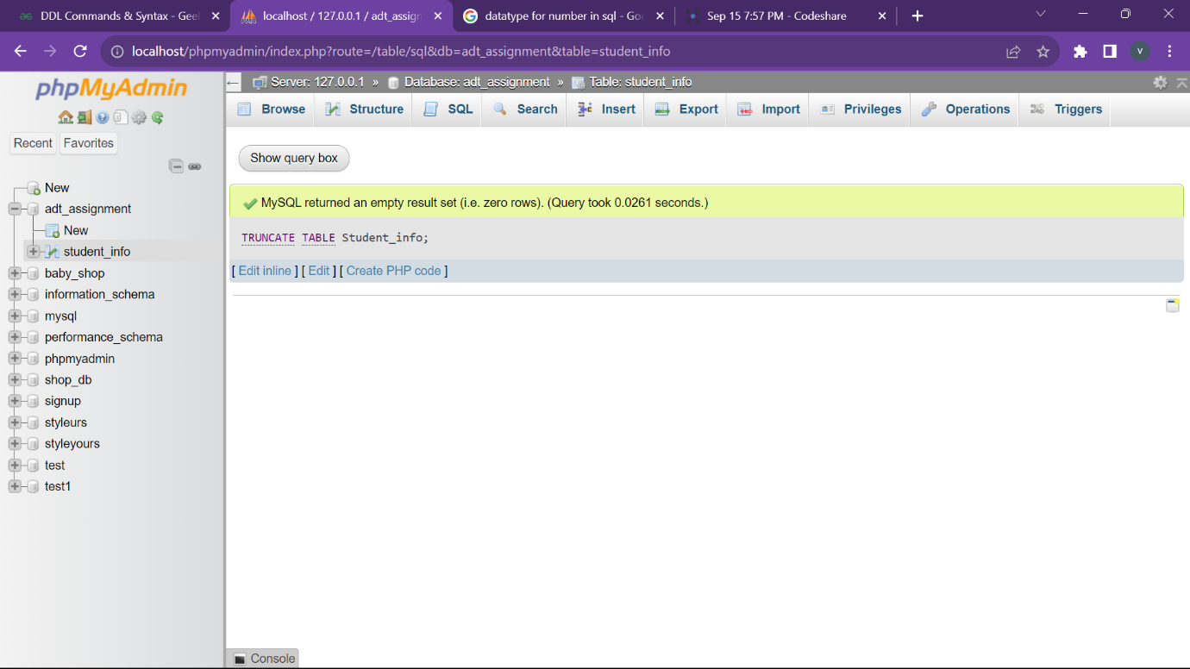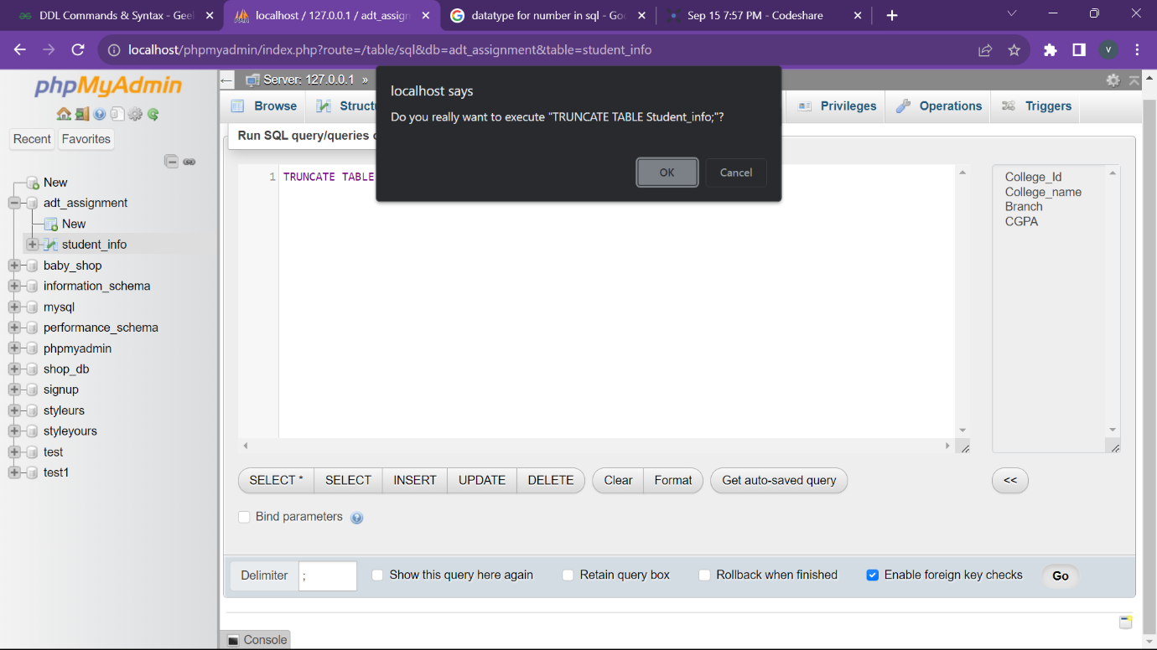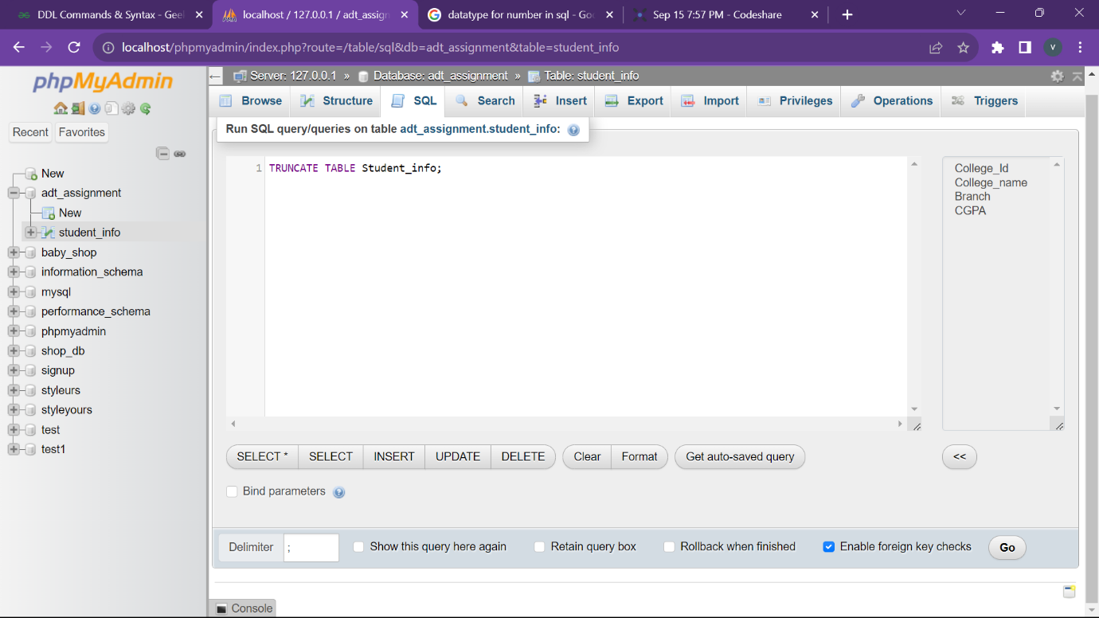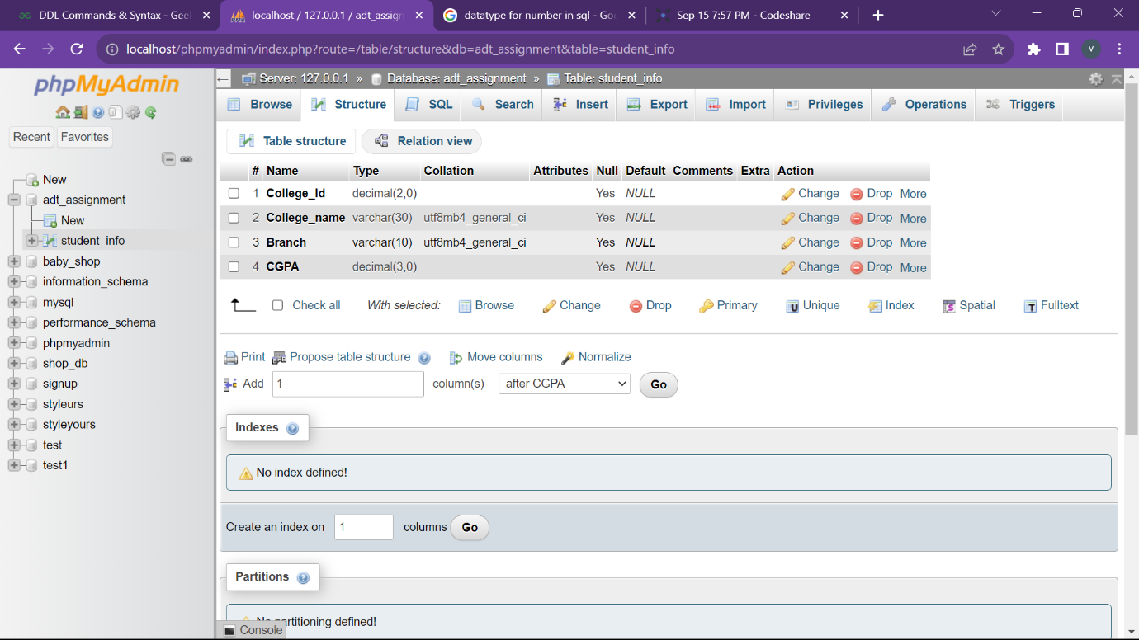

1. **Drop:** This command removes an existing table and its structure from the Database.

Syntax: DROP TABLE table_name;

Example: DROP TABLE Student_info;

